CCC Church Jerusalem Trip FAQ

- What date must I register by to secure my spot?
  - Registration is open online today and must be completed by June 12, 2026
  - $1400 must be paid by 6/12/26
  - Monthly payments of $585 each month starting in July for trip to be paid in full by January 1st 2027, ($5500)
  - If you desire to upgrade your flight, you’ll have costs and your trip must be paid in full in order to book the upgraded flight

You are not required to make monthly payments. However, you are required to meet the minimum payment amounts below.

- $1,400 paid per person must be received by June 12, 2026
- $2,400 paid per person by November 1, 2026
(Payments of any amount can be made at any time as long as the milestone amounts above are reached per person.)

- What would be the additional cost to travel business class?
  - There are 2 upgrade levels, but pricing will not be available until approximately 11 months prior to travel date (June 2026}. Here’s a rough estimate:
Premium Economy - $2000 - $4000 above currents trip cost
Business Class - $4000 - $6000 above currents trip cost

- Do we need a passport or is the Real ID sufficient?
  - MUST have a passport that is valid for 6 months after until November 30, 2027
    - If you don’t have one, we recommend you apply 8 months in advance
  - Travelers **MUST** obtain an ETA-IL (Electronic Travel Authorization) before departure. (We recommend you apply for this by the date of your final payment. Cost is approximately $7.00).

- What is the cost for the optional travel insurance?
  - The website to the company Jerusalem Tours work with is:
www.TravelInsured.com (they can provide an online quote)

- Do we need to get any immunizations before the trip?
  - No, HALLELUJAH!

Travel Insurance quotes vary, but I copied 3 quotes I got from the website for different age groups. You can go to the website and get a quote for yourself.

Quote for a 42 year old

Quote for 63 year old

Quote for 76 year old

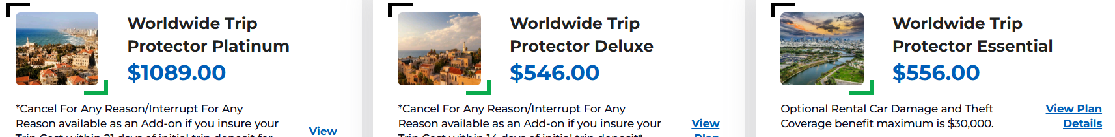

Here’s the link for answers to many other questions regarding travel to Israel:

https://docs.google.com/document/d/1hUB_yjevvyksPssZd_FJTe2ltGWCDggNZXx0AQH57qE/edit?usp=sharing

